The International NextGen Conference on AI in Biomedical Sciences (inCABS 2027)

Hosted by the Global Youth AI & STEM Foundation (GYST-AI)

Connecting Young Minds with AI and Biomedical Discovery

The Global Youth AI & STEM Foundation (GYST-AI) is pleased to announce the inaugural International NextGen Conference on AI in Biomedical Sciences (inCABS 2027).
inCABS is an annual international conference dedicated to showcasing outstanding research conducted by high school students from around the world. The conference provides a rigorous academic forum where young researchers can present original work, exchange ideas, and engage with peers who share a passion for scientific discovery and technological innovation.
Artificial intelligence is transforming biomedical sciences by enabling breakthroughs in healthcare, biological research, drug development, and medical technologies. As AI continues to reshape these fields, the next generation of scientists and innovators will play a critical role in advancing responsible, interdisciplinary research.
The inaugural inCABS welcomes original research papers that explore the application, development, and implications of artificial intelligence in biomedical sciences.
The official working language of the conference is English. All papers, presentations, and conference communications shall be conducted in English.

Conference Theme

Artificial Intelligence in Biomedical Sciences
Artificial intelligence has emerged as one of the most influential technologies in modern biomedical sciences. From accelerating genomic research and drug discovery to improving clinical diagnosis and healthcare delivery, AI is redefining how scientific discoveries are made and translated into real-world applications.
The conference welcomes research spanning computational, experimental, ethical, engineering, and interdisciplinary perspectives related to AI in biomedical sciences.

Conference Tracks

T1: AI for Healthcare, Diagnostics, and Clinical Decision Support

Artificial intelligence is increasingly supporting clinicians and healthcare systems through improved diagnostics, predictive analytics, personalized medicine, and intelligent clinical decision-making. Research in this track focuses on the development or evaluation of AI technologies that improve patient care, healthcare accessibility, and medical decision support.
Topics of interest include, but are not limited to:
- Medical image analysis
- Computer vision for healthcare
- AI-assisted diagnosis
- Clinical decision support systems
- Disease prediction and risk assessment
- Precision and personalized medicine
- Electronic health record analytics
- Wearable health technologies
- Remote patient monitoring
- Telemedicine and digital healthcare
- Healthcare workflow optimization

T2: AI in Biomedical Research, Genomics, and Drug Discovery

Artificial intelligence has become an essential tool for accelerating biomedical discovery. This track welcomes research applying AI to biological sciences, pharmaceutical research, computational biology, and laboratory science.
Students are encouraged to explore how AI can improve our understanding of biological systems, identify therapeutic targets, discover new medicines, and analyze complex biomedical datasets.
Topics of interest include, but are not limited to:
- Drug discovery
- Drug repurposing
- Protein structure prediction
- Computational biology
- Bioinformatics
- Genomics
- Transcriptomics
- Systems biology
- Biomarker discovery
- Molecular modeling
- AI-assisted laboratory automation
- Biomedical data analysis

T3: Responsible AI, Ethics, and Policy in Biomedicine

As AI becomes increasingly integrated into healthcare and biomedical research, ethical, legal, and societal considerations are becoming equally important. This track focuses on developing trustworthy, transparent, fair, and responsible AI systems while considering their broader impacts on individuals and society.
Research addressing governance, explainability, privacy, bias, and regulatory frameworks is especially encouraged.
Topics of interest include, but are not limited to:
- Ethical AI in medicine
- Algorithmic bias and fairness
- Explainable and interpretable AI
- Responsible AI development
- Biomedical data privacy
- Cybersecurity for medical AI
- Regulatory frameworks
- AI governance
- Health equity
- Patient trust and transparency
- Societal implications of AI in healthcare

T4: Emerging AI Technologies and Future Biomedical Innovation

The future of biomedical sciences will be driven by interdisciplinary innovation. This track highlights emerging technologies that combine AI with engineering, robotics, neuroscience, biotechnology, and digital health to address future biomedical challenges.
Submissions may present novel research, conceptual frameworks, prototype systems, or forward-looking analyses that demonstrate innovative applications of AI.
Topics of interest include, but are not limited to:
- Medical robotics
- AI-assisted surgery
- Brain-computer interfaces
- Biomedical engineering
- Smart prosthetics
- Digital twins in healthcare
- Internet of Medical Things (IoMT)
- Multi-modal AI
- Digital health ecosystems
- AI for biotechnology
- Future biomedical technologies

Submission Guidelines

Authors are invited to submit original, unpublished research papers relevant to the conference theme or one of the conference tracks.

Paper Requirements:

- Papers must be written in English.
- Papers are limited to six (6) pages, including figures, tables, references, and appendices.
- Submissions must present original work that has not been previously published and is not under review elsewhere.
- Authors should clearly describe the research motivation, methodology, results (where applicable), discussion, limitations, and conclusions.
- Formatting instructions and the official conference template can be found at: https://www.acm.org/publications/proceedings-template
Both individual and team submissions are welcome.

Review Process

All submitted manuscripts will undergo a rigorous peer-review process administered by the Technical Program Committee (TPC).
Each submission will be evaluated by approximately three independent reviewers with expertise relevant to the selected conference track.
Evaluation criteria include:
- Originality and innovation
- Scientific and technical merit
- Methodological rigor
- Significance and impact
- Relevance to the conference theme
- Quality of writing and organization
The Technical Program Committee will make final acceptance decisions based on reviewer recommendations and the overall quality and balance of the conference program.

Presentation and Publication

Accepted papers will be invited for presentation as either:
- Oral Presentations
- Poster Presentations
Authors of accepted papers will be required to submit a final camera-ready version incorporating reviewer feedback, where applicable.
At least one author of every accepted paper must register for the conference by the Author Registration Deadline and present the paper during the conference. Papers without a registered presenting author may be removed from the conference program and may not be included in the official conference proceedings.
Accepted and presented papers that satisfy all submission and registration requirements may be published in the official Proceedings of the International NextGen Conference on AI in Biomedical Sciences (inCABS 2027).

Awards

To recognize outstanding student research, awards are expected to include:
- Best Paper Award
- Best Oral Presentation Award
- Best Poster Presentation Award
- Outstanding Innovation Award
- Outstanding Interdisciplinary Research Award
The Organizing Committee may announce additional awards.

Academic Integrity

Authors certify that submitted work represents their own original research and that all sources, data, software, and collaborative contributions have been appropriately acknowledged.
The conference maintains a strict policy regarding plagiarism, fabrication, falsification, duplicate submission, and other forms of academic misconduct. Violations may result in rejection or withdrawal of submissions.

Eligibility

The conference welcomes submissions from high school students worldwide, either individually or as a team.
There are no geographic restrictions on participation.
All high schools (including homeschools) need to be recognized by their country's Ministry of Education or equivalent government organization.

Contact

Global Youth AI & STEM Foundation (GYST-AI)

The International NextGen Conference on AI in Biomedical Sciences (inCABS 2027)

Website:
Email: incabs2027@gmail.com
gystem.ai@gmail.com

Join us at the Inaugural inCABS 2027!

The International NextGen Conference on AI in Biomedical Sciences seeks to empower the next generation of researchers by providing an international forum for scientific exchange, collaboration, and innovation. Whether your work advances AI-driven healthcare, accelerates biomedical discovery, explores the ethical dimensions of intelligent systems, or imagines the future of medicine, we invite you to share your research with a global community of young scholars.
We look forward to welcoming you to inCABS 2027 as we begin building an international tradition of excellence in student-led biomedical AI research.
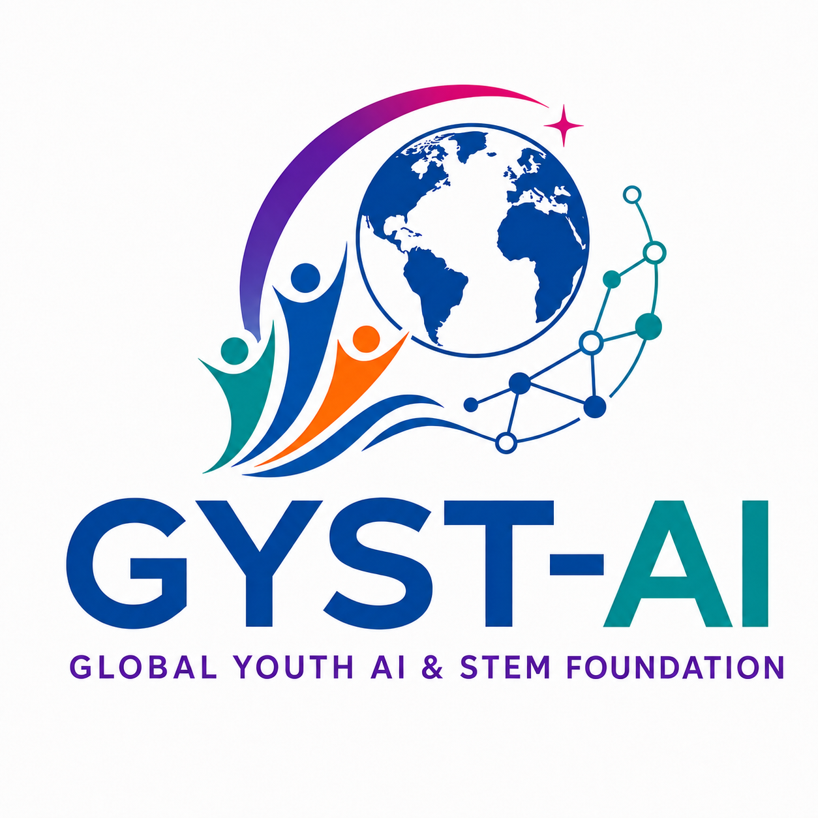
Global Youth AI & STEM Foundation (GYST-AI)
Connecting Young Minds with AI and Biomedical Discovery
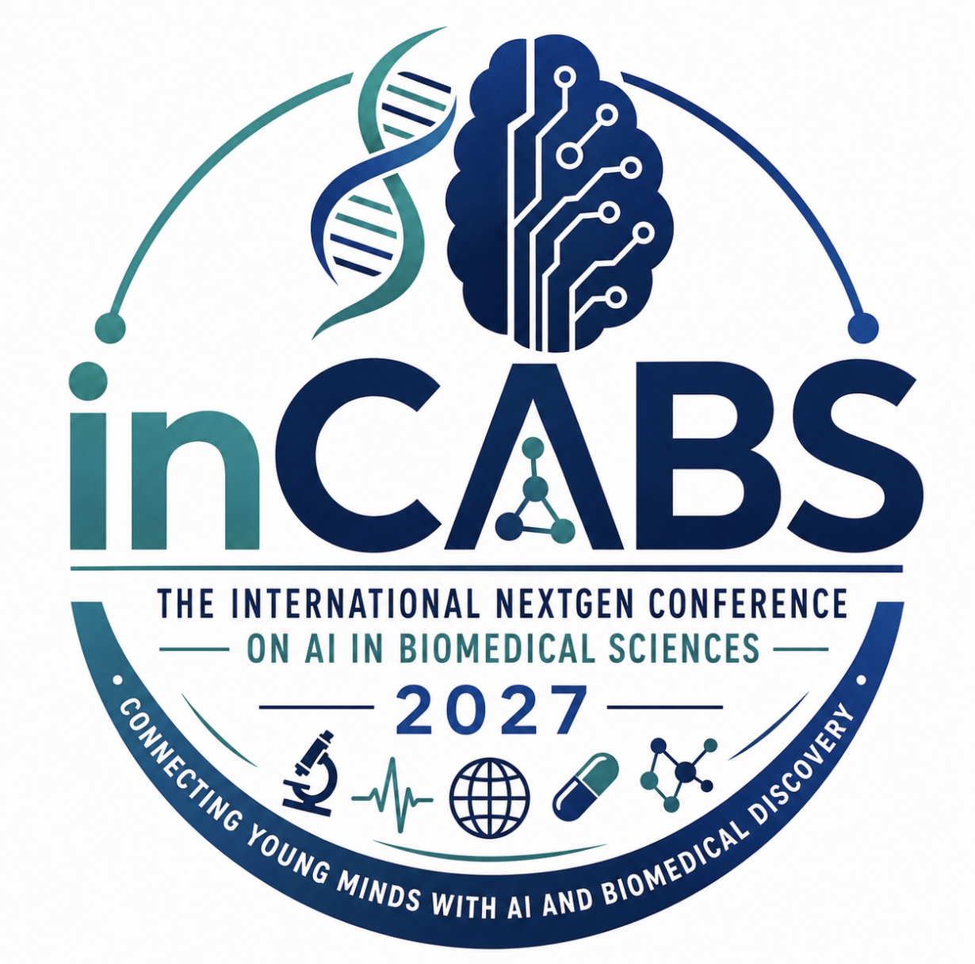

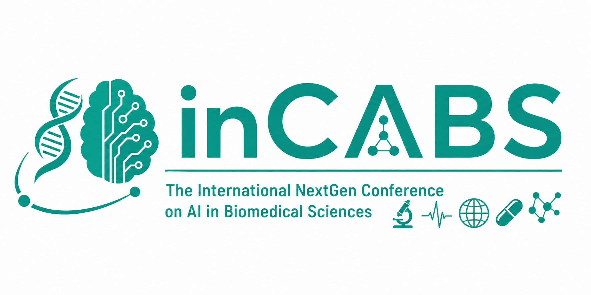

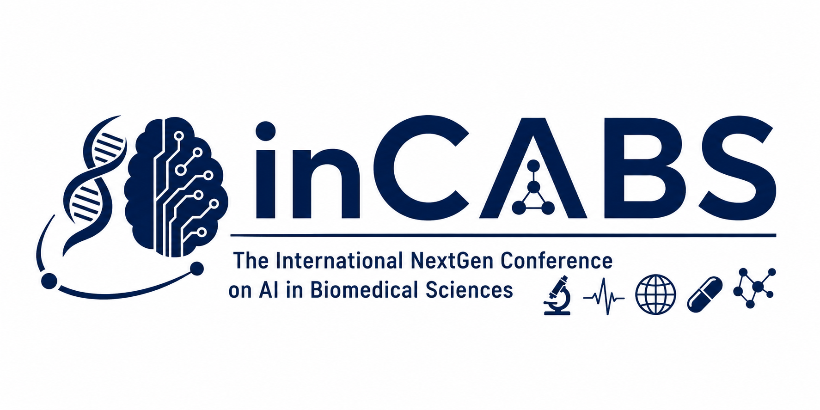

Website feedback:

- update cfp w new one (not done yet)
- important dates announced on cfp update
- on home page, add location, dates of conference, and deadlines + logo big
- at the top left corner, add inCABS logo
- use less black and the yellow on website
- update/change wording on a lot of info based on NEW cfp info
- i really like current faq, maybe add some more questions (look at iccad 26’ for ideas)
- on the committee change it to Chenlyvia Xiong, not Dr. Xiong, same for other places that say Dr.Xiong
  - Add Founding General Chair and Program Chair and Founding GYST-AI President. leave space for a photo
  - For Chenlyvia Xiong affiliation : Ronald Reagan High School, San Antonio, Texas
- when instagram and other socials are established, add them at bottom
- maybe change the contact slide (not Mostly-volunteer, it is fully volunteer. we also dont need to include gyst ai gmail–only on the gyst ai page)
- for the academic integrity tab, change tab name to “Academic Integrity & Eligibility” since that's also in there
- don't use fonts that look like coding font
- i really like the find your track thing!
- for key dates, include a date for abstract submissions (use new cfp for dates and info)
- In Committee add Zimo Wen + Program Secretary, GYST-AI Secretary under Chenlyvia Xiong
  - Zimo’s Affiliation: Williamsville East High School, Buffalo, New York also leave space for photo
- add a tab for registration with choices for early registration, author registration, and reg registration with prices (TBD, and use iccad for inspo)
- tab for travel/venue that includes the conference hotel, travel info, visa invitation letter, and things to do at the conference city location (link: https://travel.state.gov/content/travel/en/us-visas/tourism-visit/visa-waiver-program.html)
- add a button or something to become a conference sponsor
- add something to become a foundation member
- THIS HAS TO BE VISIBLE: The Microsoft CMT service was used for managing the peer-reviewing process for this conference. This service was provided for free by Microsoft and they bore all expenses, including costs for Azure cloud services as well as for software development and support.
  - This is for the CMT where people can submit their papers so put under submissions with a place to link the CMT conference when the conference is made (not made yet)
    - Once i make the conference on CMT, i can finalize the new cfp and send it
- color scheme: colors in GYST-AI logo (blue(#004faa), teal(#018c93), orange(#fe6904), purple(#5e1ba0), pink(#d90670), white, black)

